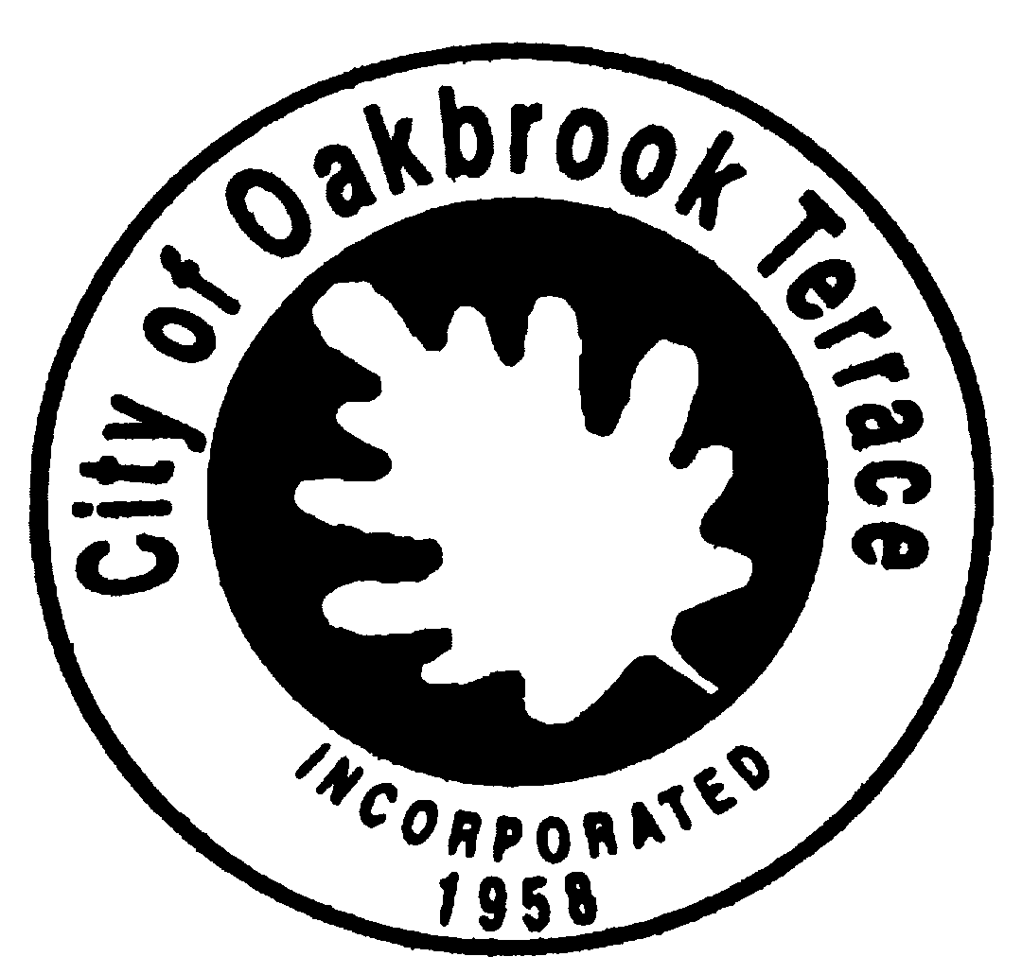

**SPECIAL COUNCIL MEETING**

**AGENDA**

**Saturday, August 20, 2022**

**10:00 A.M.**

### Dorothy Drennon Park

701 Eisenhower Road, Oakbrook Terrace, IL. 60181

1. **CALL TO ORDER**
2. **PLEDGE OF ALLEGIANCE**
3. **ROLL CALL**
4. **PRESENTATION**
5. Presentation by Christopher B. Burke Engineering representative Jebb Anderson regarding the Spring Road Tributary Restoration Project
6. **PUBLIC COMMENTS**
7. **ADJOURNMENT**

**ADJOURN**

**Next Regular Meeting is August 23, 2022**

***In compliance with the American with Disabilities Act and other applicable Federal and State laws, the City of Oakbrook Terrace meetings will be accessible to individuals with disabilities. Persons requiring auxiliary aids and services should contact the Executive Offices at 17W275 Butterfield Road, Oakbrook Terrace, Illinois 60181, or call (630) 941-8300 in advance of the meeting to inform them of their anticipated attendance.***