City of Oakbrook Terrace

City Hall
17W275 Butterfield Rd.
Oakbrook Terrace, IL 60181
www.oakbrookterrace.net

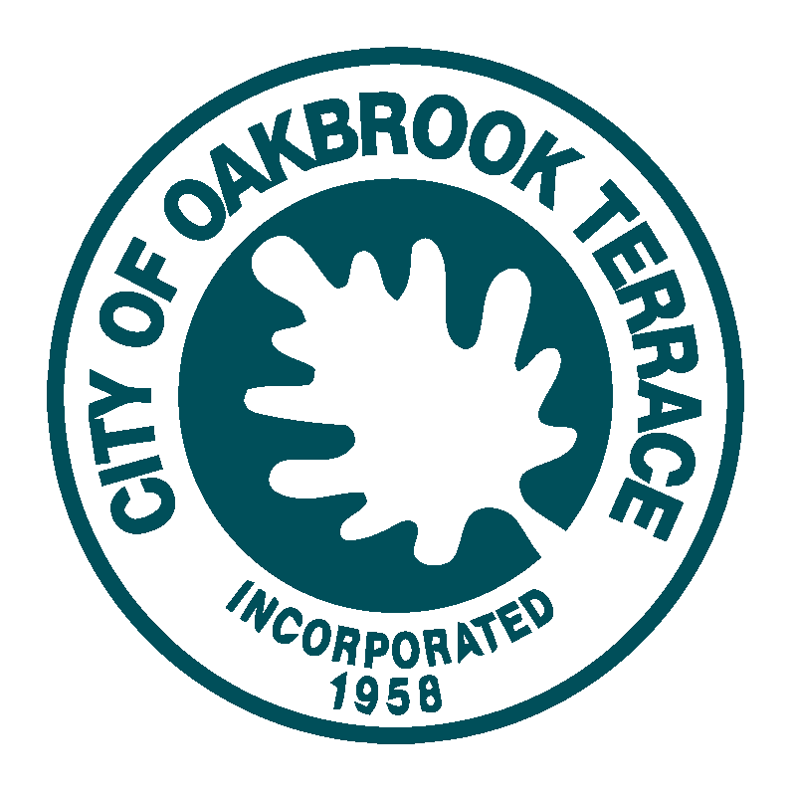
City Council Regular Meeting Agenda
Tuesday, June 9, 2026, at 7:00 PM
Council Chambers - City Hall - 17W261 Butterfield Road

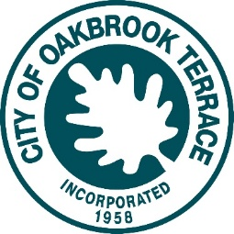
City Council Regular Meeting Agenda
Tuesday, June 9, 2026 at 7:00 PM
Council Chambers - City Hall - 17W261 Butterfield Road
www.oakbrookterrace.net
Mayor Paul Esposito
City Clerk Michael Shadley
City Council Members:
Ward 1: Alderman Charlie Barbari and Alderman Eric Biskup
Ward 2: Alderman Michael Sarallo and Alderman Dennis Greco
Ward 3: Alderman Bob Rada and Geza Petro

- CALL TO ORDER
- ROLL CALL
- PLEDGE OF ALLEGIANCE
- ADDITIONS OR DELETIONS TO THE AGENDA
- APPROVAL OF MINUTES - CHANGES OR CORRECTIONS
Approval of Meeting Minutes from May 26, 2026.
- PUBLIC PARTICIPATION
- ACTION ITEMS / CONSENT AGENDA
- Payment of City Bills: June 9, 2026, in the amount of $215,151.92.

- Ordinance No. 26-59 Authorizing the Execution of an Intergovernmental Park Use Agreement between the City of Oakbrook Terrace and the Oakbrook Terrace Park District for an Independence Day Celebration - City of Oakbrook Terrace - July 4, 2026;

- Ordinance No. 26-60 Authorizing the Execution of an Intergovernmental Park Use Agreement between the City of Oakbrook Terrace and the Oakbrook Terrace Park District - City of Oakbrook Terrace - Summer Concert Series – 2026

- An Ordinance No. 26-58 to Approve and Authorize the Execution of a Settlement Agreement between the Coalition Opposing Government Secrecy, Metric Media, LLC doing business as DuPage Policy Journal & Owen Wang and the City of Oakbrook Terrace, Illinois.

- ITEMS REMOVED FROM THE CONSENT AGENDA

- RECESS TO COMMITTEE OF THE WHOLE

- MAYOR ESPOSITO

- COMMITTEE OF THE WHOLE
  - Amended and Restated Intergovernmental Lease Agreement between the City of Oakbrook Terrace and the Oakbrook Terrace Community Park District - Terrace View Park and Parkview Plaza; and

  - Draft Ordinance Approving and Ratifying the Issuance of a Purchase Order for the Purchase of Two Police Interceptors for the City of Oakbrook Terrace.

  - Planning & Zoning Commission recommendation to grant Special Use Permits to allow a medical office and physical therapy office at the Property Commonly Known as 1S550 Route 83 in the City of Oakbrook Terrace, IL

- COUNCIL MEMBER COMMENTS
- CITY ATTORNEY
- CITY CLERK
- CITY ADMINISTRATOR
- RECONVENE THE CITY COUNCIL MEETING
- RECESS TO EXECUTIVE SESSION
- EXECUTIVE SESSION
Closed Session pursuant to Section 2(c)(21) of the Open Meetings Act for the review closed session minutes and for the semi-annual review of closed session minutes as mandated by Section 2.06 of the Open Meetings Act.

- RECONVENE THE CITY COUNCIL MEETING
- NEW BUSINESS
- ADJOURN
The next Regular City Council Meeting on Tuesday, June 23, at 7:00 pm.

In compliance with the Americans with Disabilities Act and other applicable Federal and State laws, the City of Oakbrook Terrace meetings will be accessible to individuals with disabilities. Persons requiring auxiliary aids and services should contact the Executive Offices at 17W275 Butterfield Road, Oakbrook Terrace, Illinois 60181, or call (630) 941-8300 in advance of the meeting to inform them of their anticipated attendance.

