Oakbrook Terrace Historical Committee
17W275 Butterfield Road
Oakbrook Terrace, IL 60181

Got Photographs?
Oakbrook Terrace Historical Committee
The Oakbrook Terrace Historical Committee is looking for items to be displayed and included in the archives of our City’s history.
Do you have photographs from the 1950’s? The 1960’s or even the 1970’s? Do you have photographs that show the progress of our city over the past 50 years? Do you have newspaper articles of the City? Or maybe old newsletters? How about a memory or two of what it was like to live in Oakbrook Terrace during the last 50 years?
We would like to copy your photos or articles and return the originals to you. Or, you may donate them to the Historical Committee.

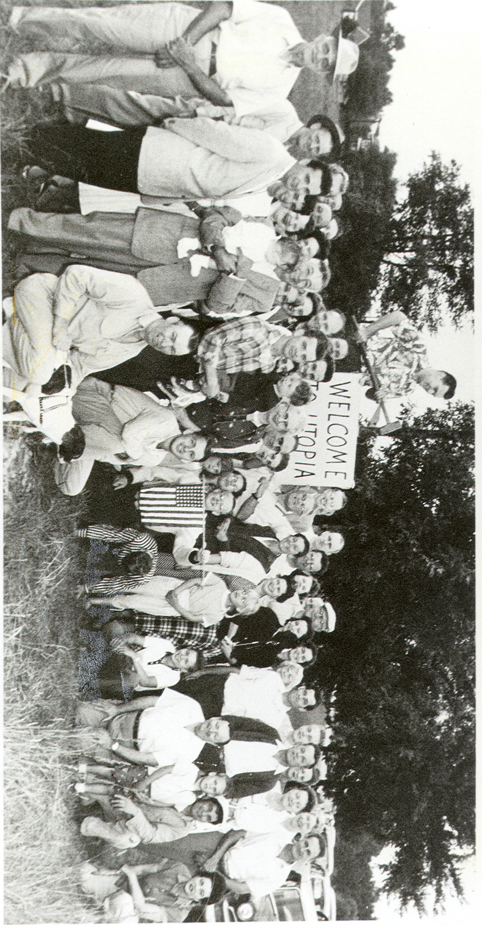

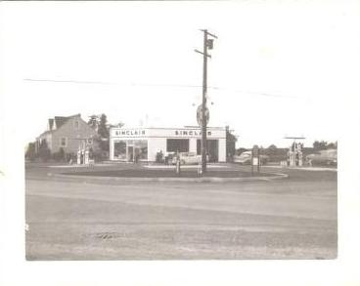
Resident
Oakbrook Terrace, IL 60181
Presorted Standard
U.S. Postage
PAID
Permit No. 288 Oakbrook Terrace, IL
1958
NW Corner Butterfield & Summit

Historical Committee
Memories of Oakbrook Terrace
Please include your name, address and telephone #
Attach additional sheets as needed

What We Need

Although the Historical Committee is just getting started we hope that with time and many volunteers we will be able to preserve and maintain the history of our beautiful City.
Please share with us your thoughts in the far column – tear off and drop at City Hall or call a Committee member listed at the bottom and we will arrange a pick up.
Have a name and address of a former resident? Jot it down and send it in!!
The New City Hall will have a display area for these items.
We are looking for any old photographs of Oakbrook Terrace.

* Homes being built (old & new)
* Past Businesses
* Parades & Special Events
* Businesses being built

Items to be displayed June 2008
at the 50th Anniversary Celebration!
We need your help NOW!

You’re Invited!

Come and see what we have and what we do!

Wednesday nights 7:30 p.m. lower level of City Hall.

Need a ride? Call us and we will arrange transportation.

Everyone is welcome – we need your help!
CONTACT US:
Bob
(630) 834-8661

or
Lori @ City Hall
(630) 941-8300 ext 338

or
OBTHistory@oakbrookterrace.net

